


Next Generation Telephony Service (NGTS)

Date: March 23, 2021
Process Name: cbts servicenow - advisory change approval board (CAB) and time

Overview

As part of the Next Generation Telephony Solution (NGTS), CBTS performs change controls and we want an advisory cab with time to be entered per each change. The change request is automatically approved and scheduled. Sign in to cbts ServiceNow to get started. For correct permissions see your manager to request ITIL and group assignment to State of Ohio Hosted VoIP.

Cbts CAB

Process Advisory Change Request

- In the menu, select Change >> Create New, click on the star to make it a Favorite for easy access in future
- Click on Advisory
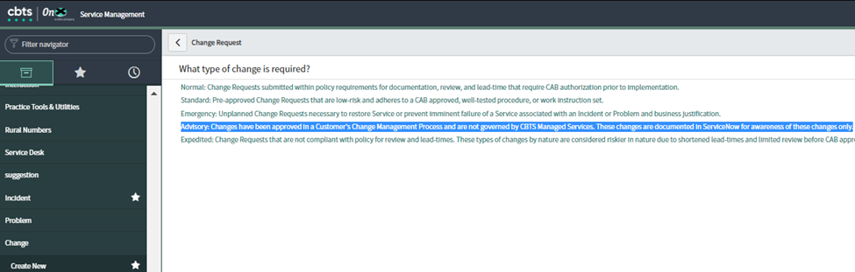
- Enter *Customer Account Name STATE OF OHIO BWC, Enter Change Owner (you) and Assignment Group (State of Ohio Hosted VoIP)
Enter Short Description and Description
  - a. Enter Configuration Items (if applicable)

JBeck,

Documentation

Page 1



Next Generation Telephony Service (NGTS)

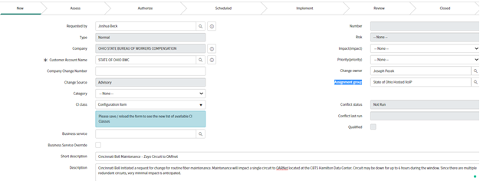

- Next, scroll down to tabs – fill out both the Schedule and Planning
Enter Planned start date / time (0000 – 2400)
Enter Planned end date / time

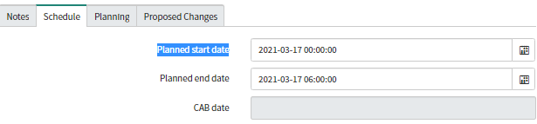

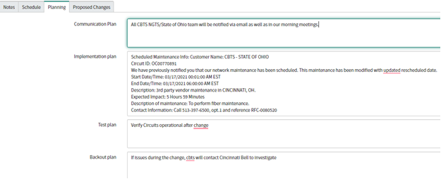

JBeck,

Documentation

Page 2

Next Generation Telephony Service (NGTS)

- Click on Save and Stay to capture the Change # and Important, you must enter Time Management in minutes. The Time is reported weekly on Mondays in the State of Ohio Change Effort and managed by Business Intelligence.
Account for most accurate time for the change being conducted, people, answering emails/calls, preparation, and always add 60 min for Josh’s admin time
    - Ex. 360 + 60 = 420 minutes
    - Submit Time Entry

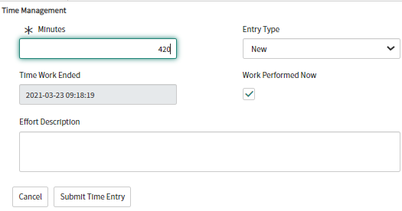
- Capture the CHG00##### and send out to Josh and others as desired to be included on the Maintenance Notification

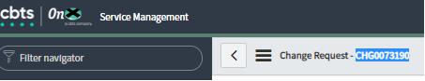

JBeck,

Documentation

Page 3

